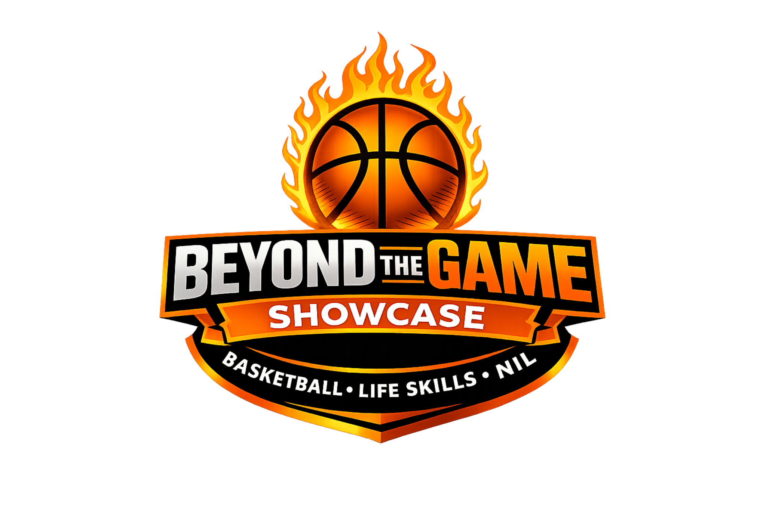
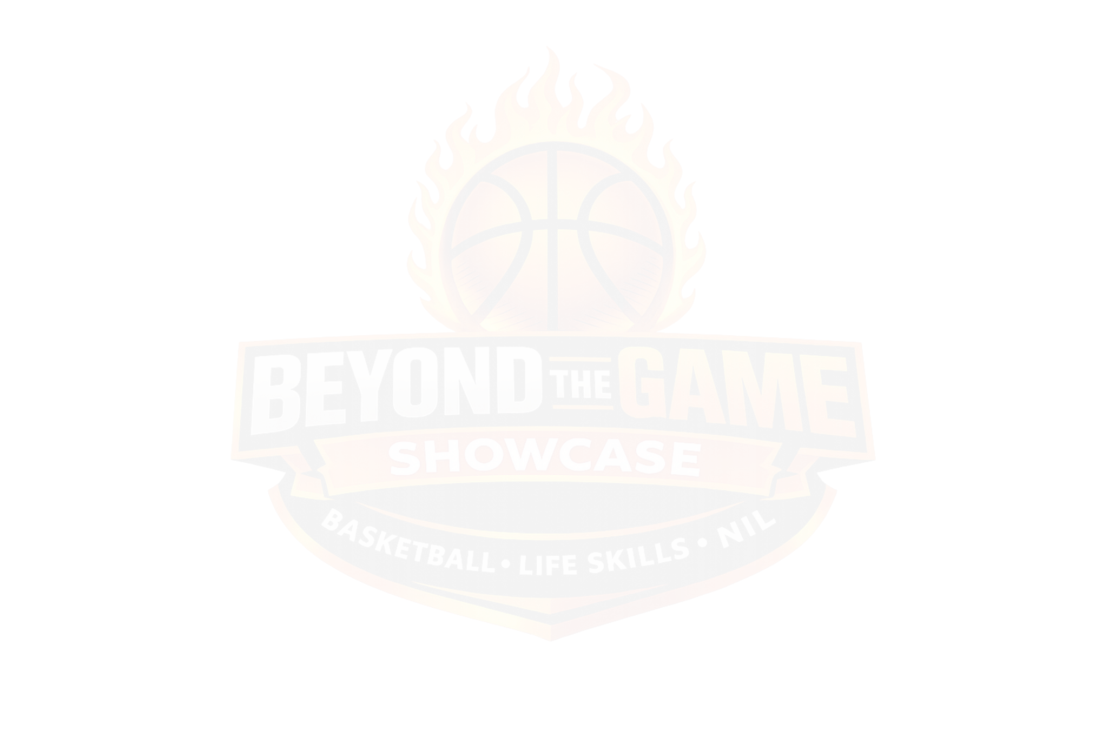

NIL MVP PACKAGE
NIL Value, Deliverables, Sponsor
Integrated Benefits

Total NIL Value Per MVP: $1,500 - $3,000
- $750 - $1,500 Cash Stipend
- Custom NIL Merch Pack (hoodie, tee, shorts, bag)
- Professional Media Package (photos + video)
- Branded NIL Social Content (co-posted with sponsors)

Each MVP receives real-world NIL exposure through your sponsors:
- Collaborative Healing Wellness Center
- Sponsored workshop: Mental Performance, Recovery &amp; Wellness

Athlete NIL Deliverable:
- 1 branded IG post + story
- Short testimonial on wellness &amp; balance
- HomeWell Care Services - Pikesville, MD
- Sponsored workshop: Leadership, Responsibility &amp; Caregiving
Athlete NIL Deliverable:
- Community-focused social post
- Optional appearance at HomeWell youth/family event
- iMC Creates
- Official NIL Media Partner

Provides:
  - Professional headshots
  - 30-60 sec highlight reel
  - NIL brand intro video
  - Athlete retains personal use rights
  - Orange Rolloffs
  - Sponsored session: Entrepreneurship &amp; Blue-Collar Business Ownership

Athlete NIL Deliverable:
  - Branded IG story/tag
  - Community shout-out content
  - Focus Movers
  - Sponsored session: Teamwork, Work Ethic &amp; Logistics
Athlete NIL Deliverable:
  - Promotional post tied to discipline &amp; preparation
  - A&amp;C; Pack and Ship
  - Sponsored session: Global Business, Logistics &amp; Opportunity
Athlete NIL Deliverable:
  - &quot;Beyond the Game&quot; business-minded post
  - Optional branded appearance
  - Minuteman Press - Columbia, MD
In-kind NIL support:
  - Athlete NIL banners
  - Event programs
  - Certificates
Athlete NIL Deliverable:
  - Branded thank-you post
  - Hoop Dreamz (iCARRe Basketball)
  - (Youth &amp; Legacy Partner)
  - Sponsored Life Skills session

Athlete NIL Deliverable:
  - Mentorship-focused content
  - Optional youth clinic appearance
  - NIL MERCH PACKAGE (Per MVP - $250 Value)
  - Custom Beyond the Game Showcase hoodie
  - NIL-branded tee
  - Backpack or duffle
  - Sponsor logo integration (tasteful &amp; compliant)

Each MVP signs:
- NIL Scope of Work
- Deliverables checklist
- Usage rights (non-exclusive)
- Payment acknowledgment
- Compliance statement
- (No athletic performance language included)

TOTAL NIL BUDGET SNAPSHOT

OPTIONAL NIL ACTIVATIONS
- Sponsor-presented MVP ceremony
- Co-branded NIL announcement graphics
- Post-event NIL recap video
- Sponsor-athlete social reposts

